1. x2 – 6x – 40 ≥ 0
(x + 4) (x – 10) ≥ 0
Correct method to find roots M1
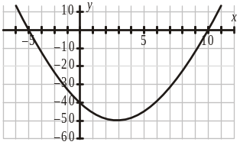

–4, 10 A1
Correct method to solve quadratic inequality e.g. + ve quadratic graph M1
x ≤ –4, x ≥ 10
x ≤ –4, x ≥ 10 A1 4
(not wrapped, not strict inequalities, no ‘and’)
[4]

2. (i) EITHER
3 (x2 + 4x) + 7
3 (x + 2)2 – 12 + 7
3 (x + 2)2 – 5
OR
3 (x2 + 2ax + a2) + b
3x2 + 6ax + 3a2 + b
6a = 12
a = 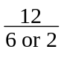 M1
a = 2 A1
3a2 + b = 7
7 – a2 or 7 – 3a2 or – a2 (their a) M1
b = –5 A1 4

(ii) x = –2 B1 1
[5]

3. (i)
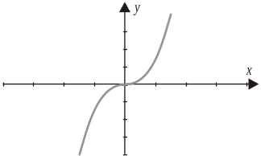

Correct sketch showing point of inflection at origin B1 1

(ii) Reflection in x-axis or reflection in y-axis
Reflection B1
In x-axis or y = 0 or y-axis or x = 0 B1 2

(iii) y = (x – p)3
y = (x ± p)3 M1
y = (x – p)3 A1 2
[5]

4. k = x3
Attempt a substitution to obtain a quadratic *M1
k2 + 26k – 27 = 0
k2 + 26k – 27 = 0 A1
k = –27,1 A1
Attempt cube root DM1
x = –3,1
x = –3,1 (no extras) A1 5
(SR: x = 1 seen www B1)
x = – 3 seen www B1)
[5]

5. (a) 2x × 3x–1
Adds indices M1
= 6x A1 2

(b) 240 × 430 = = 240 × 260
260 or 420 M1
2100 A1 2

(c) 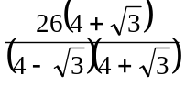
Multiply top and bottom by
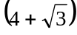 or 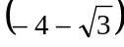 M1
= 8 + 2
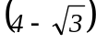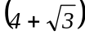 = 13 A1
8 + 2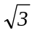 A1 3
[7]

6. (i) (x2 + 2x +1) (3x – 4) = 3x3 + 2x2 – 5x – 4 A1
Expand 2 brackets to give an expression of the form
ax2 + bx + c (a ≠ 0, b ≠ 0, c ≠ 0) and attempt to multiply by
third bracket M1
3 correct simplified terms. Completely correct A1 3

(ii) 9x2 + 4x – 5 B1ft
1 term correct B1ft 2
Completely correct (3 terms)

(iii) 18x + 4 M1
Attempt to differentiate their (ii) A1ft 2
18x + 4 (2 terms)
(SR (ii) 3ax2 + 2bx + c B1
(iii) 6ax + 2b B1)
[7]

7. (i) b2 – 4ac
Uses b2 – 4ac M1

(a) 36 – 9 × 4 = 0

(b) 100 – 48 = 52
1 correct A1

(c) 4 – 20 = –16
3 correct A1 3
SR All 3 values correct but ft used B1

(ii) (a) Fig 3
(b) Fig 2
(c) Fig 5
1 Correct matching B1
3 Correct matchings B1

(iii) (a) 1 root, touches x-axis once, line of symmetry x = –3
or root x = –3 B1

(b) 2 roots, meets x-axis twice, line of symmetry x = 5 B1 4

(c) No real roots, does not meet x-axis
1 correct comment relating roots to touching/crossing
x-axis or about line of symmetry or vertex o.e.
for one graph
2 further correct comments about roots, line
of symmetry o.e. for the other 2 graph
[7]

8. (i) Circle, centre (0, 0), radius 5
Circle centre (0, 0) B1
Radius 5 B1 2

(ii) y = 5 – 2x
x2 + (5 – 2x)2 = 25
Attempt to solve equations simultaneously M1
5x2 – 20x = 0
Substitute for x/y or correct attempt at elimination of
one variable (NOT for 2 linear equations) *M1
OR
x = 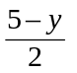
Obtain quadratic ax2 + bx + c = 0
(a ≠ 0, b ≠ 0) DM1
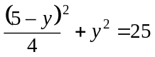
y2 – 2y – 15 = 0
Correct method to solve quadratic M1
x = 0,4 A1
y = 5, –3 A1 6
SR one correct pair www B1
SR
If solution by graphical methods:
Drawing circle, centre (0, 0) radius 5 B1
Drawing line B1
Looking for intersection M1
(0, 5) correct A1
(4, – 3) A 2
[8]

9. (i) y = 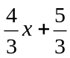
gradient =
or 1.33 or better B1 1

(ii) gradient of ⊥r = –
– seen or implied B1ft
y – 2 = –(x – 1)
Attempts equation of straight line through (1, 2) with any
gradient M1
4y + 3x = 11
y – 2 = – (x – 1) A1
3x + 4y – 11 = 0 (not aef) A1 4

(iii) P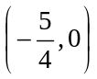
seen or implied B1
Q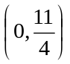
seen or implied (from a straight line
equation in (ii)) B1ft
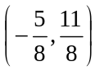 B1ft 3
aef

(iv) 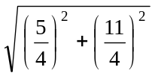 A1
Correct method to find line length using Pythagoras’ theorem M1
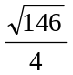 A1 3
[11]

10. (i) 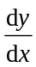 = x2 – 9
1 term correct B1
Both terms correct B1 2

(ii) x2 – 9 = 0 *M1
uses = 0
x = 3, –3 A1
y = –18, 18 A1 3
(1 correct pair A1 A0)

(iii) 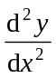 = 2x
Looks at sign of or other correct method DM1
x = 3 = 6
x = 3 minimum A1
x = –3 = –6 A1 3
x = –3 maximum
(N.B. If no method shown but min and max correctly
stated, award all 3 marks unless earlier incorrect
working) A1 3

(iv) gradient of 24x + 3y + 2 = 0 is – 8 B1
Gradient = –8
x2 – 9 = –8 M1
x = ±1 M1
one of their x values substituted in both line and curve
For line
x = 1, y = 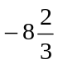
x = –1, y = 7
p = 1, q = –8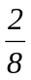seen A1 5
second x value substituted in both line and curve or
justification that first point is the correct one M1
For curve
x = 1, y =
x = –1, y = –8
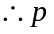 = 1, q = – 8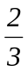 seen A1 5

Alternative methods:
Either:
Solve equations for curve and line simultaneously to get one
solution (either x = 1 or x = –2) M1
Gradient of line = –8 B1
Substitution of one x value into their gradient formula
and check for –8 M1
Substitution of other x value into gradient formula
and check for –8 or justification as above M1
Correct q value A1
Or:
Solve equations for curve and line simultaneously to get
one solution M1
Factorise to (x – 1)2 (x + 2) B1
State that a double root implies a tangent at x = 1 M2
Correct value for y A1
[13]

11. (i) 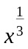 = 2
x = 8
allow embedded values
8 B1 1

(ii) 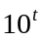 = 1
t = 0
0 B1 1

(iii) 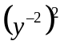 = 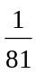
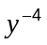 = 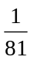
y = ±3
y = 3 B1
y = –3 B1 2
[4]

12. (i) 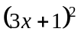 – 2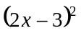
Square to get at least one 3 or 4 term quadratic M1
= 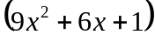 – 2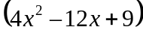
9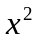 + 6x + 1 or 4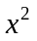 – 12x + 9 soi A1
= x2 + 30x – 17
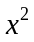 + 30x – 17 A1 3

(ii) 2x3 + 6x3 + 4x3 = 12x3
2 of 2x3, 6x3, 4x3 soi B1
N.B. www for these terms, must be positive
12
12 or 12 x3 B1 2
[5]

13. (i) 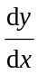 = 15x4 – 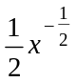
15x4 B1
kx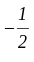 B1
cx4 – 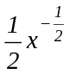 only B1 3

(ii) 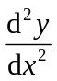 = 60x3 + 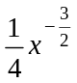
Attempt to differentiate their 2 term and
get one correctly differentiated term M1
60x3 + 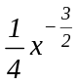 A1 2
[5]

14. (i)
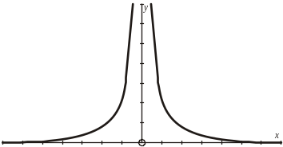

Correct curve in one quadrant B1
Completely correct B1 2

(ii)
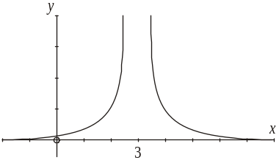

Translate (i) horizontally M1
Translates all of their (i) 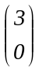 A1ft 2
3 must be labelled or stated

(iii) (One-way) stretch, sf 2, parallel to the y-axis
Stretch B1
(Scale) factor 2 B1
Parallel to y-axis o.e. B1 3
SR
Stretch B1
Sf parallel to x-axis B2
[7]

15. (i) x2 + 3x = 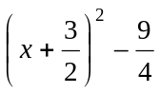
a = B1
b = o.e. B1 2

(ii) y2 – 4y – 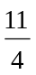 = (y – 2)2 – 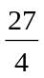
p = –2 B1
q = – 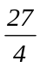 o.e. B1 2

(iii) Centre 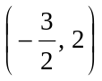
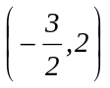 B1ft 1
N.B. If question is restarted in this part, ft from part
(iii) working only

(iv) Radius = 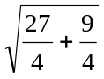
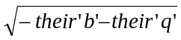 or use 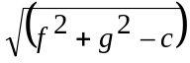 M1
= 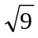
= 3
3 (±3 scores A0) A1 2
[7]

16. (i) y = x3 – 3x2 + 4
3x2 – 6x
= 3x2 – 6x
1 term correct B1
Completely correct B1
3x2 – 6x = 0
= 0 M1
3x(x – 2) = 0
Correct method to solve quadratic M1
x = 0 x = 2
x = 0, 2 A1
y = 4 y = 0
y = 4, 0 A1ft 6
SR one correct (x, y) pair www B1

(ii) 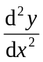 = 6x – 6
Correct method to find nature of stationary M1
points (can be a sketch)
x = 0 y” = –6 – ve max
x = 0 max B1
x = 2 y” = 6 + ve min
x = 2 min B1 3
(N.B. If no method shown but both min and
max correctly stated, award all 3 marks)

(iii) Increasing
Any inequality (or inequalities) involving both M1
their x values from part (i)
x < 0 x > 2
Allow x ≤ 0 x ≥ 2 A1 2
[11]

17. (i) x = 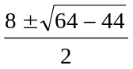
Correct use of formula M1
= 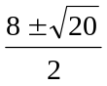
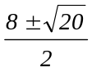 aef A1
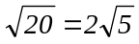 soi B1
4 ± 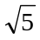 A1 4

Alternative method
(x – 4)2 – 16 + 11 = 0 M1
(x – 4)2 = 5 A1
x = 4 + A1
or 4 – A1

(ii)
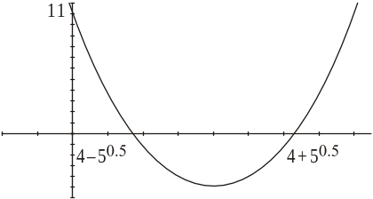

+ve parabola B1
Root(s) in correct places B1ft
Completely correct curve with roots and (0, 11)
labelled or referenced B1 3

(iii) y = x2 = (4 ± 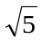)2
y = x2 soi M1
Attempt to square at least one answer from M1
part (i)
= 16 + 5 ± 8
Correct evaluation of (a + b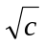)2 (a ,b, c ≠ 0) A1ft
= 21 ± 8 A1 4
[11]

18. (i) y = x2 – 5x + 15
Attempt to eliminate y M1
y = 5x – 10
x2 – 5x + 15 = 5x – 10
x2 – 10 x + 25 = 0 AG
x2 – 10 x + 25 = 0
Obtained with no wrong working seen A1 2

(ii) b2 – 4ac = 100 – 100 = 0
0......Do not allow 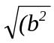– 4ac) B1 1

(iii) Line is a tangent to the curve
Tangent or ‘touches’ B1ft 1
N.B. Strict ft from their discriminant

(iv) x2 – 10x + 25 = 0
Correct method to solve 3 term quadratic M1
(x – 5)2 = 0
x = 5 y = 15
x = 5 A1
y = 15 A1 3

(v) Gradient of tangent = 5
Gradient of tangent = 5 B1
Gradient of normal = –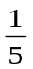
Gradient of normal = – B1ft
y – 15 = –(x – 5)
Correct equation of straight line, any gradient, M1
passing through (5, 15)
x + 5y = 80 A1 4
[11]

19. (i) Length AC = 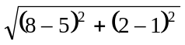
Uses 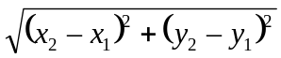 M1
= 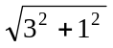
= 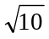
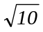 ( ± scores A0) A1

Length AB = 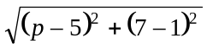
= 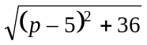
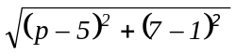 A1

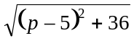 = 2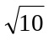
AB = 2AC (with algebraic expression) used M1
p2 – 10p + 25 + 36 = 40
p2 – 10p + 21 = 0
Obtains 3 term quadratic = 0 suitable for M1
solving or (p – 5)2 = 4
(p – 7)(p – 3) = 0
p = 7, 3
p = 7 A1
p = 3 A1 7
SR If no working seen, and one correct
value found, award B2 in place of the final
4 marks in part (i)

(ii) 7 = 3x – 14
Correct method to find x M1
x = 7
x = 7 A1
(5, 1) (7, 7)
Use 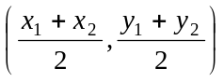 M1
Mid-point (6, 4)
(6, 4) or correct midpoint for their AB A1ft 4

Alternative method
y coordinate of midpoint = 4 M1 A1
sub 4 into equation of line M1
obtains x = 6 A1
[11]

20. (i) 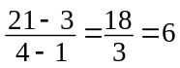
Uses 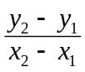 M1
6 (not left as 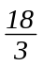) A1 2

(ii) 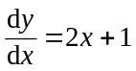 B1
2 × 3 + 1 = 7 B1 2
[4]

21. (i) 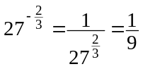
or 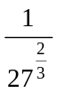 = 9 or 3–2 soi M1
A1 2
(ii) 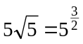 = 32 B1 1

(iii) 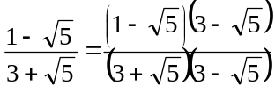 M1
Multiply numerator and denominator by conjugate
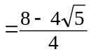 B1
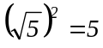 soi
= 2 –
2 – 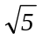 A1 3
[6]

22. (i) 2x2 + 12x + 13 = 2(x2 + 6x) + 13
a = 2 B1
b = 3 B1
= 2[(x + 3)2 – 9] + 13
13 – 2b2 or 13 – b2 or 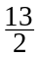– b2 (their b) M1
= 2(x + 3)2 – 5 A1 4
c = –5

(ii) 2(x + 3)2 – 5 = 0 M1
Uses correct quadratic formula or completing
square method
2(x + 3)2 = A1
x = 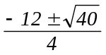 or (x + 3)2 =
x = –3 ±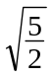 A1 3
x = –3 ±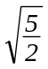 or –3 ± 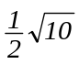
[7]

23. (i) (x – 4)(x – 3)(x + 1)
x2 – 7x +12 or x2 – 2x – 3 or x2 – 3x – 4 seen B1
≡ (x2 – 7x2 + 12)(x + 1)
≡ x3 + x2 – 7x2 – 7x + 12x + 12
≡ x3 – 6x2 + 5x + 12
Attempt to multiply a quadratic by a linear factor M1
or attempt to list an 8 term expansion of all 3 brackets
x3 – 6x2 + 5x + 12 (AG) obtained A1 3
(no wrong working seen)

(ii)
(iii)
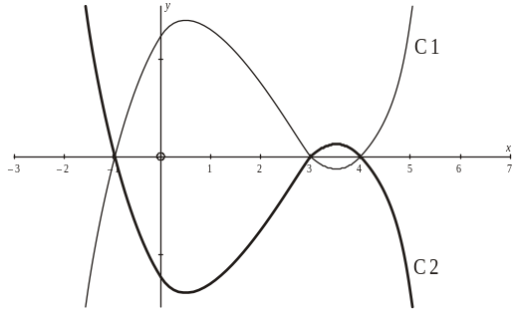
+ve cubic with 3 roots (not 3 line segments) B1
(0, 12) labelled or indicated on y-axis B1
(– 1, 0), (3, 0), (4, 0) labelled or indicated on x-axis B1 3
Reflect their (ii) in either x- or y-axis M1
Reflect their (ii) in x-axis A1ft 2
[8]

24. (i) 1 < 4x – 9 < 5
2 equations or inequalities both dealing with all 3 terms M1
10 < 4x < 14
2.5 < x < 3.5
2.5 and 3.5 seen oe A1
2.5 < x < 3.5 (or ‘x > 2.5 and x < 3.5’) A1 3

(ii) y2 ≥ 4y + 5
y2 – 4y – 5 = 0 soi B1
y2 – 4y – 5 ≥ 0
Correct method to solve quadratic M1
(y – 5)(y + 1) ≥ 0
or values –1, 5 A1
(SR If both values obtained from trial and
improvement, award B3)
y ≤ – 1, y ≥ 5
Correct method to solve inequality M1
y ≤ –1, y ≥ 5 A1 5
[8]

25. (i) x4 – 10x2 + 25 = 0
Let y = x2
Use a substitution to obtain a quadratic *M1
or (x2 – 5) (x2– 5) = 0
y2 – 10y + 25 = 0
(y – 5)2 = 0
Correct method to solve a quadratic dep*M1
y = 5
5 (not x = 5 with no subsequent working) A1
x2= 5
x = ± A1 4

(ii) y = 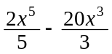+ 50x + 3
2x4 or – 20x2 oe seen B1
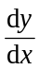 = 2x4 – 20x2 + 50
2x4 – 20x2 + 50 (integers required) B1 2

(iii) 2x4 – 20x2 + 50 = 0
their = 0 seen (or implied by correct answer) M1
x4 – 10x2 + 25 = 0
which has 2 roots
2 stationary points www in any part A1 2
[8]

26. (i) y = x2 – 5x + 4
y = x – 1
x2 – 5x + 4 = – l
Substitute to find an equation in x (or y) M1
x2 – 6x + 5 = 0
Correct method to solve quadratic M1
(x – 1)(x – 5) = 0
x = 1 x = 5
x = 1, 5 A1
y = 0, y = 4
y = 0, 4 A1 4
(N.B. This final A1 may be awarded in
part (ii) if y coordinates only seen in part(ii))
SR one correct (x, y) pair www B1

(ii) 2 points of intersection B1 1

(iii) EITHER
x2 – 5x + 4 = x + c has 1 solution
x2 – 5x + 4 = x + c has 1 solution seen or implied M1
x2 – 6x + (4 – c) = 0
b2 – 4ac = 0
Discriminant = 0 or (x – a)2 = 0 soi M1
36 – 4(4 – c) = 0
36 – 4(4 – c) = 0 or 9 = 4 – c A1
c = –5
c = – 5 A1 4

OR
= 1 = 2x – 5
Algebraic expression for gradient of curve = non-zero M1
gradient of line used
2x – 5 = 1 A1
x = 3 y = –2
x = 3 A1
–2 = 3 + c
c = –5
c = –5 A1 4
SR c = –5 without any working B1
[13]

27. (i) Height of box = 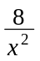
Area of 1 vertical face = 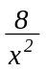× x = 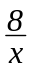 *B1
4 vertical faces = 4 × *B1
= 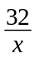
Total surface area = x2 + x2 +
A = 2x2 +
Correct final expression B1 dep on both** 3

(ii) 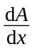 = 4x – 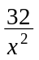
4x B1
Kx–2 B1
–32x–2 B1 3

(iii) 4x – = 0
= 0 soi M1
4x3 = 32
x = 2 A1

Check for minimum M1
Correctly justified A1 4
SR If x = 2 stated www but with no
evidence of differentiated expression(s)
having been used in part (iii) B1
[10]

28. (i) 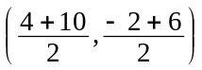
Uses 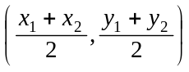 M1
(7, 2)
(integers required) A1 2

(ii) 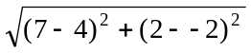
Uses 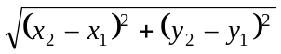 M1
= 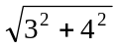
= 5 A1 2

(iii) (x – 7)2 + (y – 2)2 = 25
(x – 7)2 and (y – 2)2 used (their centre) B1ft
r2 = 25 used (their r2) B1ft
(x – 7)2 + (y – 2)2 = 25 cao B1 3

Expanded form:
–14x and –4y used B1ft
r = 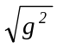 + f2 –c used B1ft
x2 +y2 –14x – 4y + 28 = 0 B1 cao
By using ends of diameter:
(x – 4)(x – 10) + (y + 2)(y – 6) = 0
Both x brackets correct B1
Both y brackets correct B1
Final equation fully correct B1

(iv) Gradient of AB = 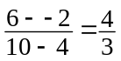
oe B1
Gradient of tangent = 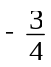 B1ft
Correct equation of straight line through A, M1
any non–zero gradient
y – –2 = (x – 4) A1
3x + 4y = 4
a ,b, c need not be integers A1 5
[12]

29. 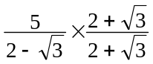
Multiply top and bottom by ± (2 + 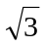) M1
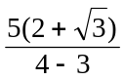
(2 + 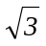)(2 – ) = 1 (may be implied) A1
= 10 + 5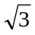
10 + 5 A1 3
[3]

30. (i) 1 B1 1
(ii) 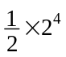 M1
2–1 = or 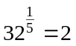 or 25 = 32 soi
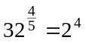 or 16 seen or implied M1
= 8 A1 3
[4]

31. (i) 3x – 15 ≤ 24
3x ≤ 39
Attempt to simplify expression by multiplying out brackets M1
M1
x ≤ 13
or
x – 5 < 8
Attempt to simplify expression by dividing through by 3 M1
x ≤ 13 A1 2

(ii) 5x2 > 80
Attempt to rearrange inequality or equation to combine
the constant terms M1
x2 > 16
x > 4
x > 4 B1
or x < –4
fully correct, not wrapped, not ‘and’ A1 3
SR B1 for x >4, x < –4
[5]

32. Let y = 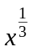 *M1
Attempt a substitution to obtain a quadratic or
factorise with 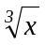 in each bracket
y2 +3y – 10 = 0
(y – 2)(y + 5) = 0
Correct attempt to solve quadratic DM1

y = 2, y = –5
Both values correct A1
x = 23, x = (–5)3
Attempt cube DM1
x = 8, x = –125
Both answers correctly followed through A1 ft 5
SR B2 x = 8 from T & I
[5]

33. (i)
Reflection in either axis M1
Correct reflection in x axis A1 2

(ii) (1, 3)
Correct x coordinate B1
Correct y coordinate B1 2
SR B1 for (3, 1)
(iii) Translation B1
2 units in negative x direction B1 2
[6]

34. (i) 2(x2 – 12x + 40)
a = 2 B1
= 2[(x – 6)2 – 36 + 40]
b = 6 B1
= 2[(x – 6)2 + 4]
80 – 2b2 or 40 – b2 or 80 – b2 or 40 – 2b2 (their b) M1
= 2(x – 6)2 + 8
c = 8 A1 4

(ii) x = 6 B1 ft 1
(iii) y = 8 B1 ft 1
[6]

35. (i) 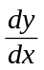 = 5 B1 1
(ii) y = 2x–2
x2 soi B1
= –4x–3 B1
– 4xc
kx–3 B1 3

(iii) y = 10x2 – 14x + 5x – 7
Expand the brackets to give an expression of form
ax2 + bx + c (a ≠ 0, b ≠ 0, c ≠ 0) M1
y = 10x2 – 9x – 7
Completely correct (allow 2 x-terms) A1
= 20x – 9
1 term correctly differentiated B1ft
Completely correct (2 terms) B1 ft 4
[8]

36. (i) = 9 – 6x – 3x2
Attempt to differentiate y or –y (at least one correct term) *M1
3 correct terms A1
At stationary, points, 9 – 6x – 3x2 = 0
Use of = 0 (for y or –y) M1

3(3 + x)(1 – x) = 0
x = –3 or x = 1
Correct method to solve 3 term quadratic DM1
x = –3, 1 A1
y = 0, 32
y = 0, 32 (1 correct pair www A1 A0) A1 ft 6

(ii) 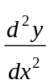 = –6x – 6 M1
Looks at sign of , derived correctly from k, or other
correct method
When x = –3, > 0
x = –3 minimum A1
When x = 1, < 0
x = 1 maximum A1 3

(iii) –3 < x < 1
Uses the x values of both turning points in inequality/inequalities M1
Correct inequality or inequalities. Allow ≤ A1 2
[11]

37. (i) Gradient = 4
Gradient of 4 soi B1
y – 7 = 4(x – 2)
Attempts equation of straight line through (2, 7) with any gradient M1
y = 4x – 1 A1 3

(ii) 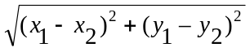 M1
Use of correct formula for d or d2 (3 values correctly substituted) M1
= 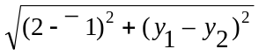
= 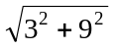 A1
= 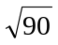
= 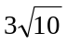
Correct simplified surd A1 3

(iii) Gradient of AB = 3 B1
Gradient of perpendicular line = –
SR Allow B1 for – B1 ft
Midpoint of AB = 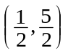 B1

y – = –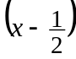 B1
Attempts equation of straight line through their midpoint with any
non-zero gradient M1
x + 3y – 8 = 0
y – = –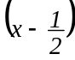 A1
x + 3y – 8 = 0 A1 6
[12]

38. (i) Centre (–1, 2)
Correct centre B1
(x + 1)2 – 1 + (y – 2)2 – 4 – 8 = 0
Attempt at completing the square M1
(x + 1)2 + (y – 2)2 = 13

Radius √13
Correct radius A1 3
Alternative method:
Centre ( –g, –f ) is ( –1, 2) B1
g2 + f2 – c M1
Radius = √13 A1

(ii) (2)2 + (k – 2)2 = 13
Attempt to substitute x = –3 into circle equation M1
(k – 2)2 = 9
k – 2 = ± 3
Correct method to solve quadratic M1
k = –1
k = –1 (negative value chosen) A1 3

(iii) EITHER
y = 6 – x
Attempt to solve equations simultaneously M1
(x + 1)2 + (6 – x – 2)2 = 13
Substitute into their circle equation for x/y M1
or attempt to get an equation in 1 variable only
(x + 1)2 + (4 – x)2 = 13

x2 + 2x + 1 + 16 – 8x + x2 = 13
2x2 – 6x + 4 = 0
Obtain correct 3 term quadratic A1
2(x – 1)(x – 2) = 0
Correct method to solve quadratic of form M1
ax2 + bx + c = 0 (b ≠ 0)

x = 1, 2
Both x values correct A1
∴y = 5, 4
Both y values correct A1 6
or
one correct pair of values www B1
second correct pair of values B1

OR
x = 6 – y
(6 – y + 1)2 + (y – 2)2 = 13
(7 – y)2 + (y – 2)2 = 13
49 – 14y + y2 + y2 – 4y + 4 = 13
2y2 – 18y + 40 = 0
y = 4, 5
2(y – 4)(y – 5) = 0
:. x = 2, 1
SR
T & I M1 A1 One correct x (or y) value
...............A1 Correct associated coordinate
[12]

39. (4x2 + 20x + 25) – (x2 – 6x + 9) = 3x2 + 26x + 16
Square one bracket to give an expression of M1
the form ax2 + bx + c (a ≠ 0, b ≠ 0, c ≠ 0)
One squared bracket fully correct A1
All 3 terms of final answer correct A1

Alternative method using difference
of two squares:
(2x + 5 + (x – 3))(2x + 5 – (x – 3))
2 brackets with same terms but different signs M1

= (3x + 2)(x + 8)
= 3x2 + 26x + 16
One bracket correctly simplified A1
All 3 terms of final answer correct A1 3
[3]

40. (a) (i)
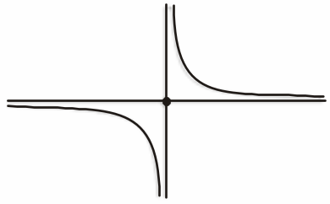

Excellent curve for in either quadrant B1
Excellent curve for in other quadrant B1 2
SR B1 Reasonably correct curves in
1st and 3rd quadrants

(ii)
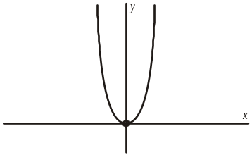

Correct graph, minimum point at origin,
symmetrical B1 1

(b) Stretch B1
Scale factor 8 in y direction
or scale factor ½ in x direction B1 2
[5]

41. (i) 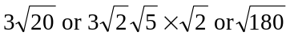 or 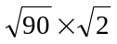 M1
= 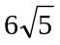
Correctly simplified answer A1 2

(ii) 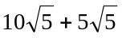 M1
Attempt to change both surds to B1
One part correct and fully simplified
= 15
cao A1 3
[5]

42. (i) (–4)2 – 4 × k × k
Uses b2 – 4ac (involving k) M1
= 16 – 4k2 = 0 M1

(ii) 16 – 4k2 = 0
Attempts b2 – 4ac = 0 (involving k) or
attempts to complete square (involving k)
k2 = 4
k = 2 B1
or k = –2 B1
[5]

43. (i) Length = 20 – 2x
Expression for length of enclosure in terms of x M1
Correctly shows that area = 20x – 2x2 A1 2
AG
Area = x(20 – 2x) = 20x – 2x2

(ii) 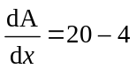
Differentiates area expression M1
For max, 20 – 4x = 0
x = 5 only M1
Uses 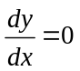
Area = 50 A1
A1 4
[6]

44. Let y = (x + 2)2
y2 + 5y – 6 = 0
Substitute for (x + 2)2 to get
y2 + 5y – 6 (= 0) B1
(y + 6)(y – 1) = 0
Correct method to find roots M1
Both values for y correct A1
y = –6 or y = 1
(x + 2)2 = 1
Attempt to work out x M1
x = –1
One correct value A1
or x = –3
Second correct value and no extra real values A1 A1 6
[6]

45. (a) f(x) = x + 3x-1
Attempt to differentiate M1
f’(x) = 1 – 3x–2
First term correct A1
x–2 soi www A1
Fully correct answer A1 4

(b) 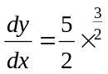
Use of differentiation to find gradient M1
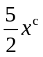 B1
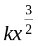 B1
When x = 4, 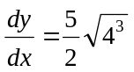 = 20 M1
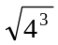 soi
SR If 0 scored for first 3 marks, award
B1 if 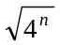 correctly evaluated. A1 5
[9]

46. (i) (x + 4)2 – 16 + 15 B1
a = 4
= (x + 4)2 – 1
15 –their a2 M1
cao in required form A1 3

(ii) (–4, –1)
Correct x coordinate B1 ft
Correct y coordinate B1 ft 2
Correct method to find roots M1
–5, –3 A1

(iii) x2 + 8x + 15 > 0
(x + 5)(x + 3) > 0
Correct method to solve quadratic inequality M1
eg + ve quadratic graph
x < –5, x > –3
x < –5, x > –3 A1 4
(not wrapped, strict inequalities, no ‘and’)
[9]

47. (i) (x – 3)2 – 9 + y2 – k = 0
(x – 3)2 soi B1
(x – 3)2 + y2 = 9 + k
Centre (3, 0)
Correct centre B1
9 + k = 42 M1
k = 7
Correct value for k (may be embedded) A1 4
Alternative method using expanded
form:
Centre (–g, –f) M1
Centre (3, 0) A1
4 = 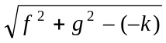 M1
k = 7 A1

(ii) (3 – 3)2 + y2 = 16
y2 = 16
Attempt to substitute x = 3 into M1
original equation or their equation
y = 4
y = 4 (do not allow ± 4) A1

Length of AB = 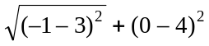
Correct method to find line length M1
using Pythagoras’ theorem
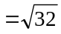
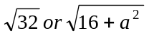 A1 ft
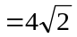 A1cao 5

(iii) Gradient of AB = 1 or 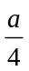 B1 ft
y – 0 = m(x + 1) or y – 4 = m
Attempts equation of straight line M1
through their A or B with their gradient
(x – 3)
y = x + 1
Correct equation in any form with A1 3
simplified constants
[12]

48. (i) (3x + 1)(x – 5) = 0
Correct method to find roots M1
x = 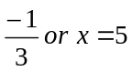
Correct brackets or formula A1
Both values correct A1 3
SR B1 for x = 5 spotted www

(ii) Positive quadratic (must be reasonably symmetrical) B1
y intercept correct B1
Both x intercepts correct B1 ft 3
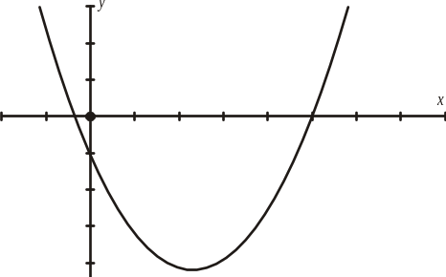
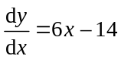
Use of differentiation to find gradient of curve M1*
6x – 14 = 4
Equating their gradient expression to 4 M1*
x = 3 A1
On curve, when x = 3, y = –20
Finding y co ordinate for their x value A1 ft
–20 = (4 × 3) + c
N.B. dependent on both previous M marks M1 dep
c = –32 A1 6
Correct equation A1 6
c = –32 A1
[12]

49. 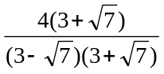 M1
Multiply top and bottom by conjugate
= 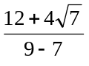 B1
9 ± 7 soi in denominator
= 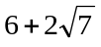 A1 3
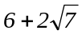
[3]

50. (i) x2 + y2 = 49 B1 1
x2 + y2 = 49
(ii) x2 + y2 – 6x – 10y – 30 = 0
(x – 3)2 – 9 +(y – 5)2 – 25 – 30 = 0 M1
32 52 30 with consistent signs soi
(x – 3)2 + (y – 5)2 = 64
r2 = 64
r = 8 A1 2
8 cao
[3]

51. a(x + 3)2 + c = 3x2 +bx + 10 B1
a = 3 soi
3(x2 + 6x + 9) + c = 3x2 + bx + 10 B1
b = 18 soi
3x2 + 18x + 27 + c = 3x2 + bx + 10 M1
c = 10 – 9a or c = 10 – 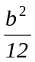
c = –17 A1 4
c = –17
[4]

52. (i) p = – 1 B1 1
p = – 1
(ii) 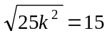 M1
Attempt to square 15 or attempt to square root 25k2
25k2 = 225
k2 = 9 A1
k = 3
k = ± 3 A1 3
k = –3

(iii) 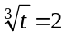 M1
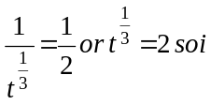
t = 8 A1 2
t = 8
[6]

53. (i)
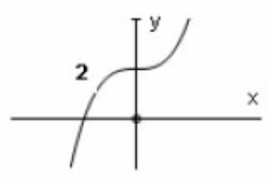
B1
+ve cubic
B1 2
+ve or -ve cubic with point of inflection at (0, 2) and no max/min points

(ii)
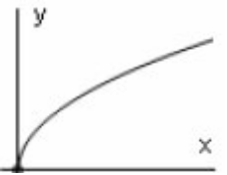
B1
curve with correct curvature in +ve quadrant only
B1 2
completely correct curve

(iii) Stretch B1
stretch
scale factor 1.5 B1
factor 1.5
parallel to y-axis B1 3
parallel to y-axis or in y-direction
[7]

54. (i) EITHER
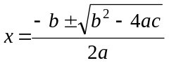 M1
Correct method to solve quadratic
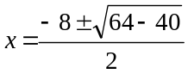
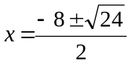 A1
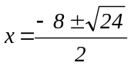
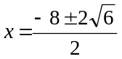
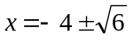 A1 3
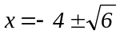

OR
(x + 4)2 – 16 + 10 = 0
(x + 4)2 = 6
x + 4 = 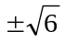 M1 A1
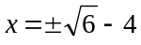 A1

(ii)
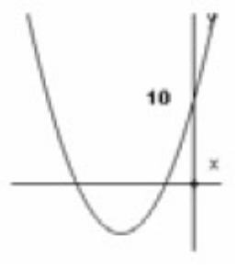
B1
+ve parabola
B1
parabola cutting y-axis at (0, 10) where (0, 10) is not min/max point
B1 3
parabola with 2 negative roots
M1
x ≤ lower root x ≥ higher root (allow < , > )

(iii) 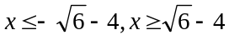 A1 ft 2
Fully correct answer, ft from roots found in (i)
[8]

55. (i) Gradient = 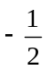 B1 1
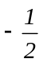

(ii) y – 5 = 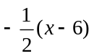 M1
Equation of straight line through (6, 5) with any non-zero numerical gradient
B1 ft
Uses gradient found in (i) in their equation of line
2y – 10 = – x + 6
x + 2y – 16 = 0 A1 3
Correct answer in correct form (integer coefficients)

(iii) EITHER
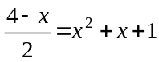 * M1
Substitute to find an equation in x (or y)
4 – x = 2x2 + 2x + 2
2x2 + 3x – 2 = 0
(2x – 1) (x + 2) = 0 DM1
Correct method to solve quadratic

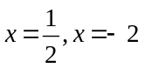 A1
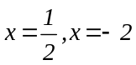
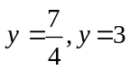 A1 4
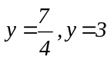
SR one correct (x,y) pair www B1

OR
y = (4 – 2y)2 + (4 – 2y) + 1 * M
y = 16 – 16y + 4y2 + 4 – 2y + 1
0 = 21 – 19y + 4y2
0 = (4y – 7) (y – 3) DM
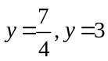 A1
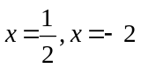 A1
[8]

56. (i) 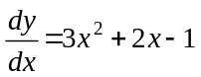 * M1
Attempt to differentiate (at least one correct term)
A1
3 correct terms
At stationary points,
3x2 + 2x – 1 = 0 M1
Use of 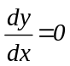
(3x – 1) (x + 1) = 0 DM1
Correct method to solve 3 term quadratic

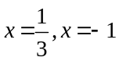 A1
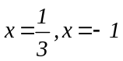
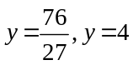 A1 6
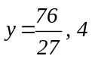
SR one correct (x,y) pair www B1

(ii) 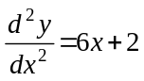 M1
Looks at sign of 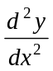 for at least one of their x-values or other correct method
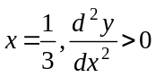 A1
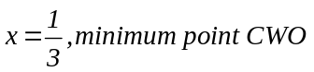
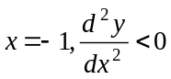 A1 3
x = −1, maximum point CWO

(iii) –1 < x < M1
Any inequality (or inequalities) involving both their x values from part (i)
A1 2
Correct inequality (allow < or ≤ )
[11]

57. (i) Gradient of AB = 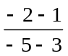 B1
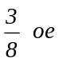
=
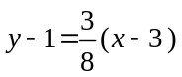 M1
Equation of line through either A or B, any non zero numerical gradient
8y – 8 = 3x – 9
3x – 8y – 1 = 0 A1 3
Correct equation in correct form

(ii) 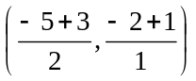 M1
Uses 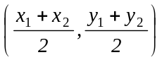
=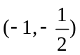 A1 2
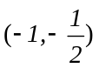

(iii) 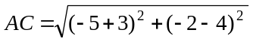 M1
Uses 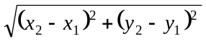
=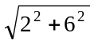
=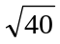 A1
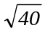
=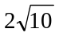 A1 3
Correctly simplified surd

(iv) Gradient of AC =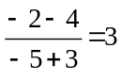 B1
3 oe
Gradient of BC =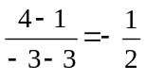 B1
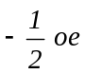
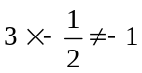 so lines are not perpendicular M1
Attempts to check m1 × m2
A1 4
Correct conclusion www
[12]

58. (i) 24x2 − 3x−4 B1
24x2
B1
kx−4
B1
− 3x−4
48x + 12x−5 M1
Attempt to differentiate their (i)
A1 5
Fully correct

(ii) 8x3 + 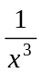 = –9
8x6 + 1 = –9x3
8x6 + 9x3 + 1= 0 * M1
Use a substitution to obtain a 3-term quadratic
Let y = x3 DM1
Correct method to solve quadratic
8y2 + 9y + 1 = 0
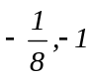
(8y + 1)(y + 1) = 0 A1

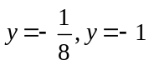 M1
Attempt to cube root at least one of their y-values
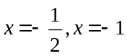 A1 5
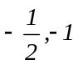
SR one correct x value www B1
SR for trial and improvement:
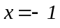 B1
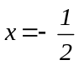 B2
Justification that there are no further solutions B2
[10]

59. (i) n = –2 B1
(ii) n = 3 B1
(iii) M1
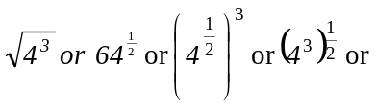
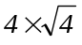 with brackets correct if used
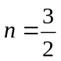 A1
[4]

60. (i) M1
y = (x ± 2)2
y = (x – 2)2 A1
(ii) y = –(x3 – 4) B1
oe
[3]

61. (i) 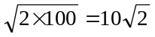 B1
(ii) 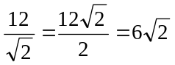 B1
(iii) M1
Attempt to express 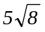 in terms of 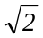
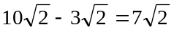 A1
[4]

62. 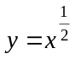
2y2 – 7y + 3 = 0 M1 *
Use a substitution to obtain a quadratic or
factorise into 2 brackets each containing 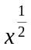
(2y – 1)(y – 3) = 0 M1dep
Correct method to solve a quadratic

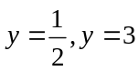 A1
M1
Attempt to square to obtain x
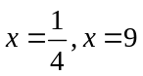 A1
SR If first M1 not gained and 3 and 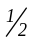 given as final answers, award B1
[5]

63. M1
Attempt to differentiate
A1
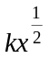
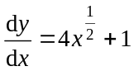 A1
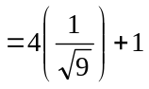 M1
Correct substitution of x = 9 into their
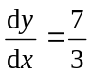 A1
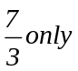
[5]

64. (i) (x – 5)(x + 2)(x + 5) B1
x2 – 3x –10 or x2 + 7x + 10 or x2 – 25 seen
= (x2 – 3x – 10)(x + 5) M1
Attempt to multiply a quadratic by a linear factor
= x3 +2x2 – 25x – 50 A1

(ii)
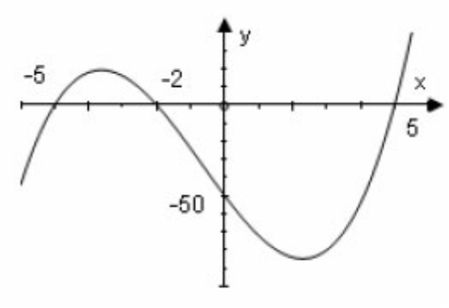
B1
+ve cubic with 3 roots (not 3 line segments)
B1√
(0, –50) labelled or indicated on y-axis
B1
(–5, 0), (–2, 0), (5, 0) labelled or indicated on x-axis
and no other x- intercepts
[6]

65. (i) 8 < 3x – 2 < 11 M1
2 equations or inequalities both dealing with all 3 terms resulting in a < kx < b
10 < 3x < 13 A1
10 and 13 seen
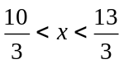 A1

(ii) x (x + 2) ≥ 0 M1
Correct method to solve a quadratic
A1
0, –2
M1
Correct method to solve inequality
x ≥ 0, x ≤ – 2 A1
[7]

66. (i) 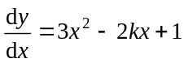 B1
One term correct
B1
Fully correct

(ii) 3x2 – 2kx + 1 = 0 when x = 1 M1
their 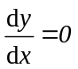 soi
3 – 2k +1 = 0 M1
x = 1 substituted into their their
k = 2 A1√

(iii) 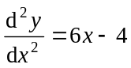 M1
Substitutes x = 1 into their and looks at sign
When x = 1,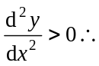 min pt A1
States minimum CWO

(iv) 3x2 – 4x + 1 = 0 M1
their
(3x – 1)(x – 1) = 0 M1
correct method to solve 3-term quadratic
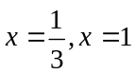
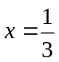 A1
WWW at any stage
[10]

67. (i) B1
(x – 2)2 and (y – 1)2 seen
(x – 2)2 + (y – 1)2 = 100 B1
(x ± 2)2 + (y ± 1)2 = 100
x2 + y2 – 4x – 2y – 95 = 0 B1
correct form

(ii) (5 – 2)2 + (k – 1)2 = 100 M1
x = 5 substituted into their equation
(k –1)2 = 91 or k2 – 2k – 90 = 0 A1
correct, simplified quadratic in k (or y) obtained
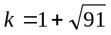 A1
cao

(iii) distance from (–3, 9) to (2, 1)
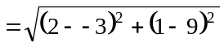 M1
Uses (x2 – x1) + (y2 – y1)2
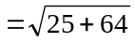 A1
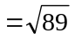
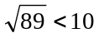so point is inside B1
compares their distance with 10 and makes consistent conclusion

(iv) gradient of radius = 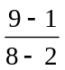 M1
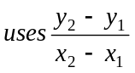
= A1
oe
gradient of tangent =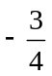 B1√
oe

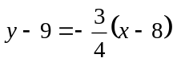 M1
correct equation of straight line through (8, 9),
any non-zero gradient
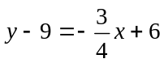
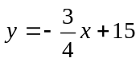 A1
oe 3 term equation
[14]

68. (i) 2(x2 – 3x) + 11 B1
p = 2
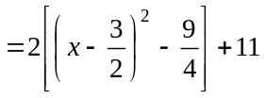 B1
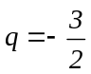
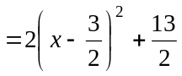 M1
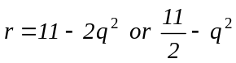
A1
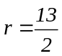

(ii) 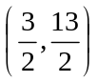 B1√
B1√
(iii) 36 – 4 × 2 × 11 M1
uses b2 – 4ac
= –52 A1
(iv) 0 real roots B1
cao

(v) 2x2 – 6x + 11 = 14 –7x M1 *
substitute for x/y or attempt to get an equation
in 1 variable only
2x2 + x – 3 = 0 A1
obtain correct 3 term quadratic
(2x + 3)(x – 1) = 0 M1dep
correct method to solve 3 term quadratic
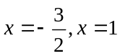 A1
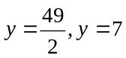 A1
SR If A0 A0, one correct pair of values,
spotted or from correct factorisation www B1
[14]

